New Delhi, India

April 22, 2024



Data Manager GUIDE

*Justice Services Statistical System (JSSS)*

Table of Contents

1.0 INTRODUCTION 3

2.0 USER INTERFACE 4

2.1 HOME 4

**2.1.1 ABOUT** 6

**2.1.2 INFORMATION KIOSK** 8

**2.1.3 CONTACT** 9

2.2 EXPLORE DATA 10

# 1.0 INTRODUCTION

The **Justice Services Statistical System (JSSS)** Dashboard is developed as a web-based platform to strengthen the Justice sector. The platform will be used to collect, collate, track, monitor and report on justice service indicators at area level for better decision-making. The dashboard comprises of various modules including the user interface and data management. Users with appropriate roles has the access to their restricted modules.

The User Interface application contains the following modules -

1. Home
2. Explore Data

Each of these modules are explained in detail.

# 2.0 USER INTERFACE

The **Justice Services Statistical System (JSSS)** **Dashboard** is a web-based tool which can be accessed through a web browser (recommended browser - Google Chrome latest version). Enter URL <https://jsss.itechmission.org/dashboard/> in the web browser. The first page you will get to view is the home page. The home page has the options available to navigate through all the modules of the user interface application – **Home** and **Explore Data**. Let us learn about how to use these modules.

## 2.1 HOME

This is the landing page of the portal which consist of three sections. The first section presents the branding guidelines, platform’s logo and header menu to navigate to the other modules of the portal The **homepage** of JSSS serves as the central hub for users to engage with the platform. It is carefully designed to provide a seamless user experience and easy navigation using bars as well. The first section also features visually appealing infographics and a brief description about the platform. (see below figure).

The second section presents the **Key Facts** related to the justice services in an animated card view. Each card shows the following information’s:

* Area Name
* Indicator
* Data Value
* Year
* 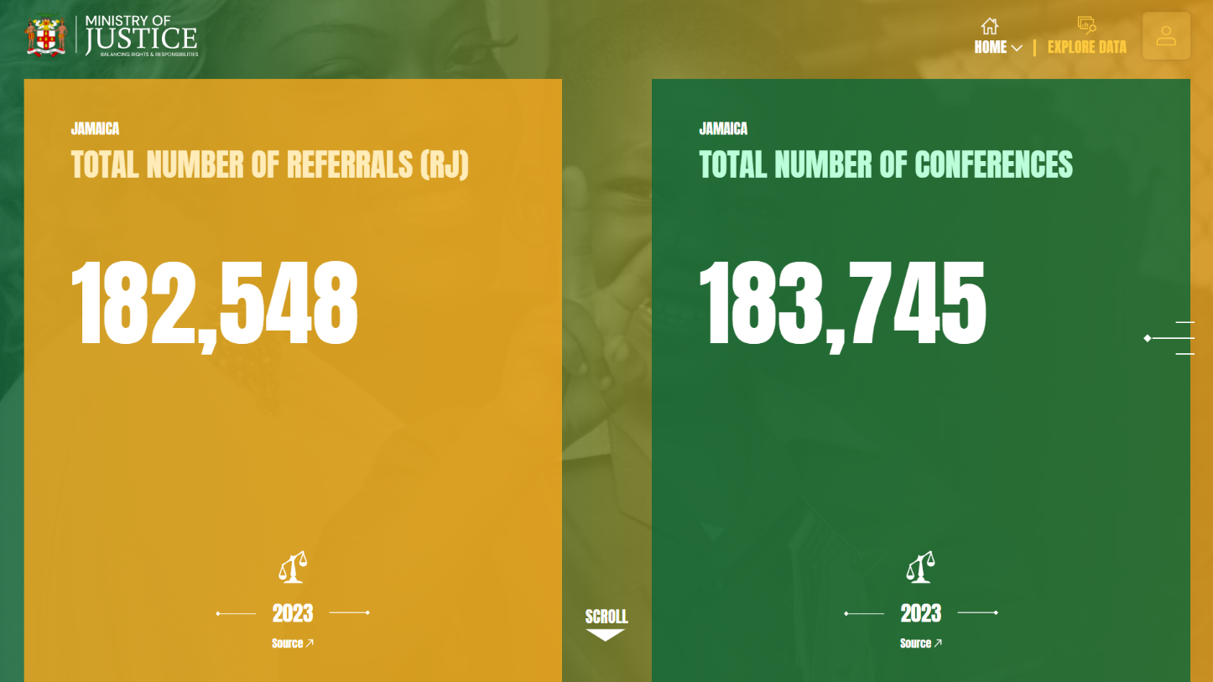Data Source

The third section provides users with a comprehensive overview of the platform's features and functionalities. Additionally, it includes a footer featuring partner logos and menu options for seamless navigation. (see below figure)

### **2.1.1 ABOUT**

The home module is further categorized in three sub modules: - **About, Information Kiosk and Contact.**

Click on the **About** option from the home dropdown in the header to navigate to the module. This module allows you to view detailed information about the Justice services statistical system and its frameworks.

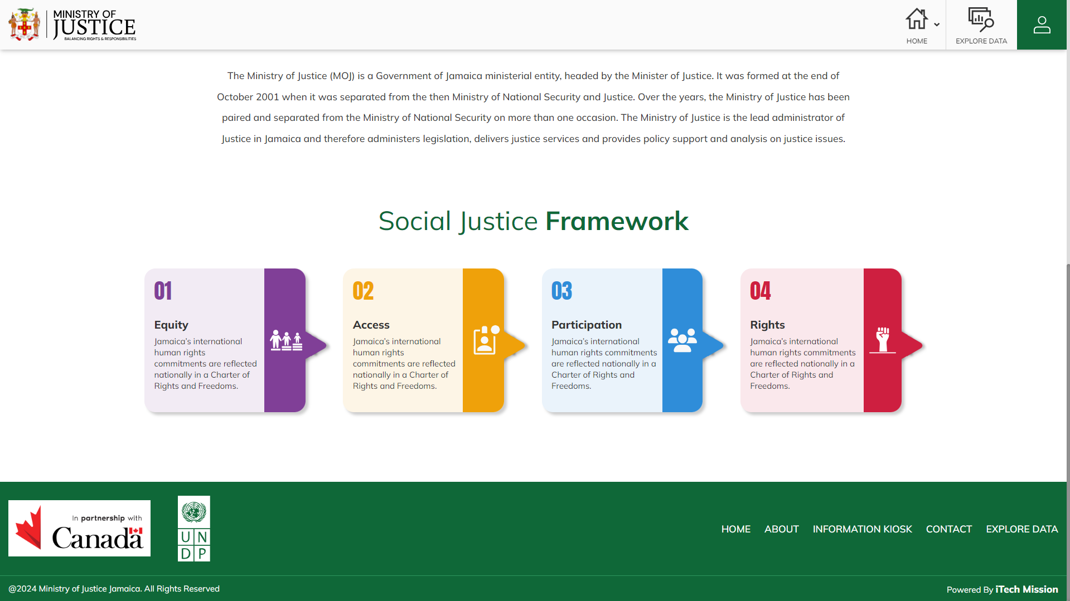**Social Justice Framework** of the services is shown with the help of cards. Each card represents a crucial aspect of the framework, providing a comprehensive understanding of their approach of social justice. (see below figure)

### **2.1.2 INFORMATION KIOSK**

Click on the **Information Kiosk** option from the home dropdown in the header to navigate to the module. This module presents the reference documents relevant to the justice services statistical system. You will be able to view the resources grouped by category. You can also Search resources by entering text in search bar available at the top right corner. Additionally, you can Sort the resources in alphabetical order and in the order of its date of creation by clicking on the respective sorting icons (see below figure)

Click on the **Arrow** icon present below every resource to read the full description of the resource.

### **2.1.3 CONTACT**

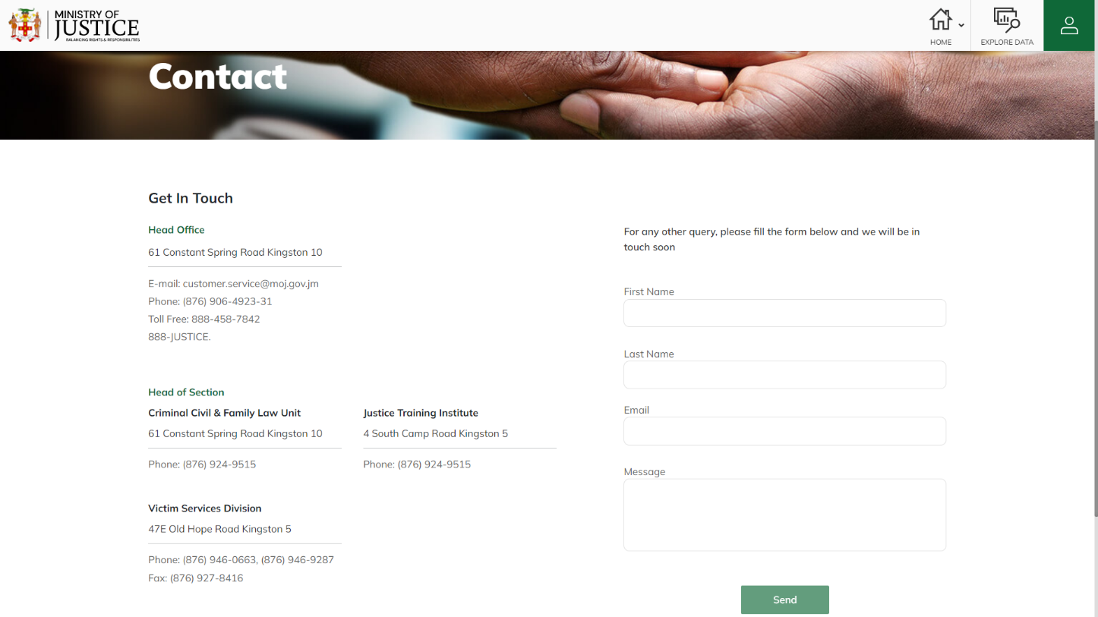Click on the **Contact** option from the home dropdown in the header to navigate to the module. This module provides contact details for the Justice Ministry, like phone numbers, email addresses, and office locations for head office, different sections and departments. It also has a query form where you can ask questions. You have to add your First Name, Last Name, Email, and Message, then click the send button to submit your query.

## 2.2 EXPLORE DATA

Click on the **Explore Data** option from the navigation bar. This is a topic and subtopic driven module. Select the topic and subtopic from the dropdown *(by default Child Diversion (CD) as topic and CD Feedback forms as subtopic is selected)* After selecting the topic and subtopic, you will be able to view data of all the indicators by topic and sub-topic. Each indicator’s data is shown in a separate widget and each widget contains the following information:

* Indicator-Unit
* Indicator Metadata
* Visualization data
* Legend for the data
* Source of the data
* Subgroup of the data
* Time period of the data
* Area of the data
* Burger menu

The **Burger Menu** in the widget allows to perform the following actions:

Line Chart

Bar Chart

Column Chart

Pie Chart

Area Chart

Tree Chart

Table View

Label on/off

Legend show/hide

Swap

Download

Full screen

Share

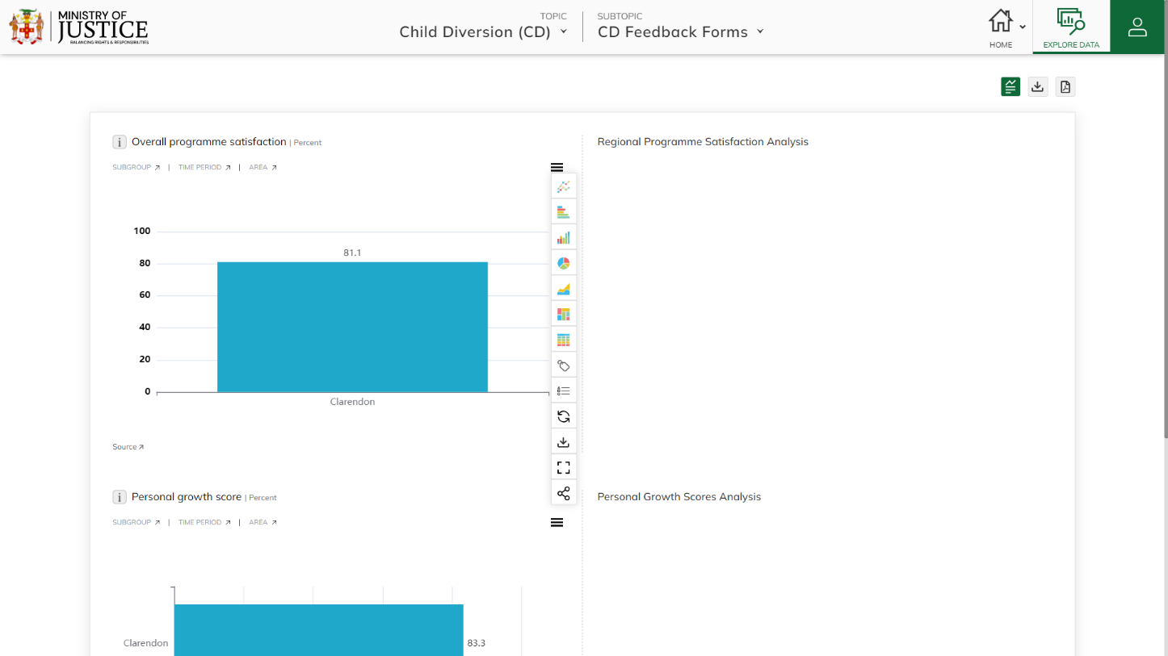The **Static** and **Dynamic analysis** of each indicator is shown to the right side of the visualization widget. The dynamic analysis data changes dynamically when hovering on the time period or subgroup based on the calculations added in the data manager application.

Click on the **Analysis** icon to show analysis along with the Indicator.

Click on the **Download icon** available at the top right corner to download data in CSV and click on the PDF icon to download the data in PDF format